Description

CloneOut – Clone of the game Breakout, circa 1972 by Atari, Inc. Will have all components of original game, plus power-ups and penalties. Ten original levels will be designed.

Type of Application

Will be a desktop application, written in Java 8

Software used

Eclipse Luna – software development

GIMP/Inkscape – Artwork

Famitracker/Ardour – Music & sound effects

Git – Version control

Github – online hosting & documentation

Group

Nope. Just me.

Development Model

uhhhhhh

User Interface

See fig 1

Needs analysis

Audience – casual PC gamers – dads, moms, kids, etc

Environment – Multi-platform, can run on any machine w/ java

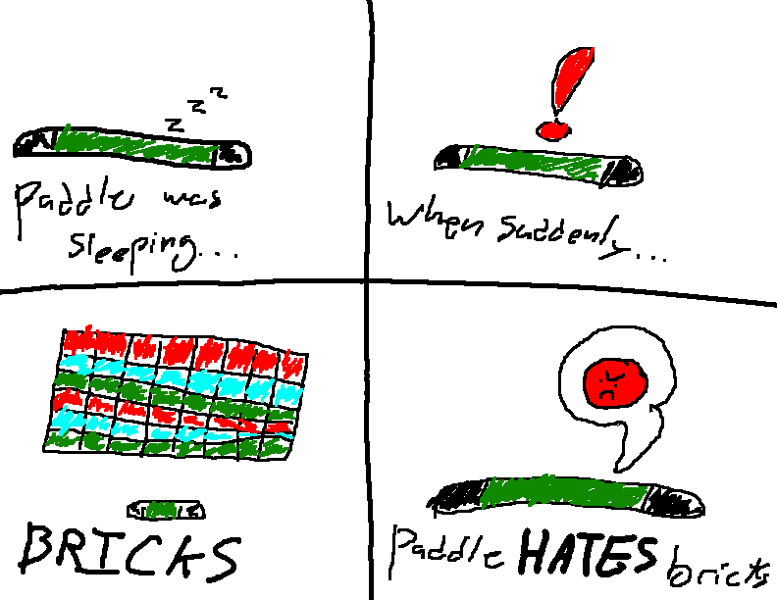 Features needed – menu items, game engine, levels

Storyboard

Flowchart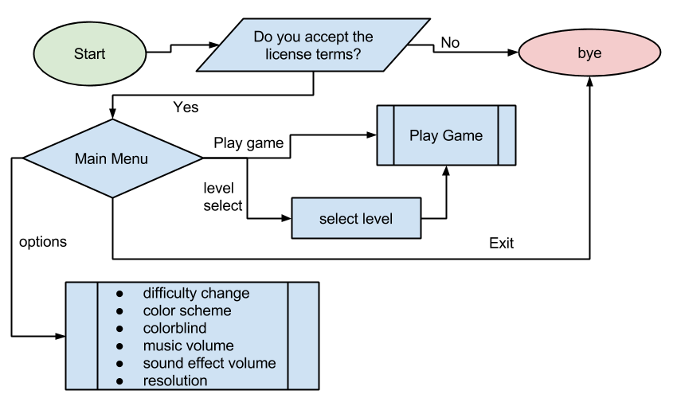

SCRUM

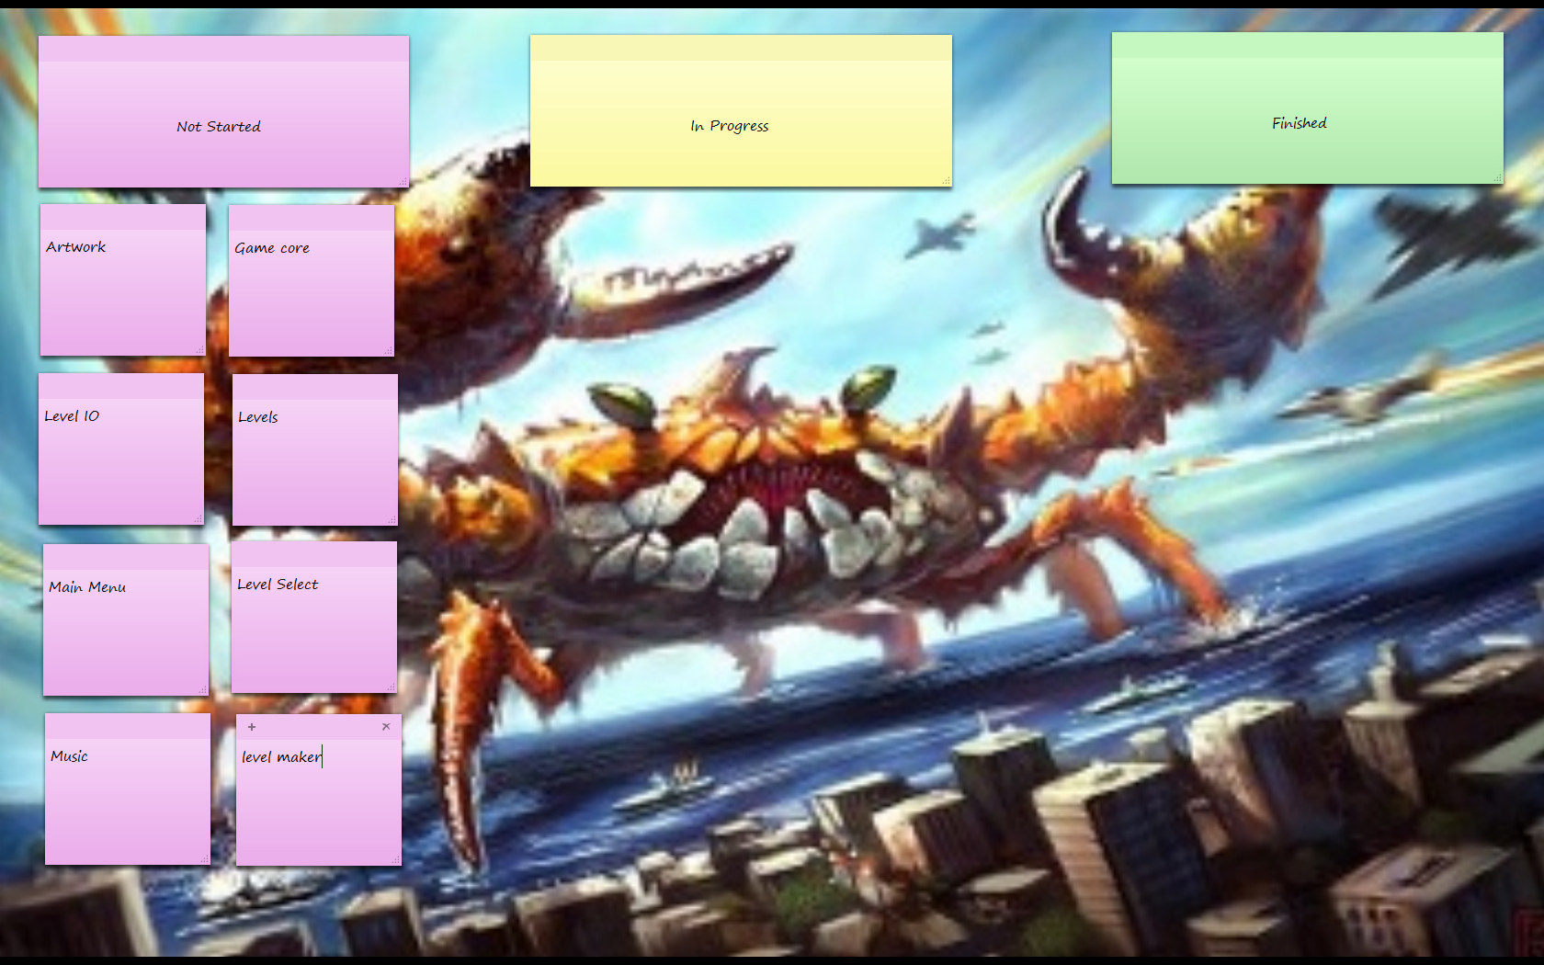

Timeline

Week 1) get components done, create game core, start menu

Week 2) finish menu, add music, add levels, add level save, add options if time

UML Diagrams

I have no time sorry oops

Quality Assurance

I will be constantly checking my work as I code; any bugs I find will be immediately stamped out. I will also be having beta testers come and give feedback. I will be keeping my bugfixes documented on the github commit comments.

Version Plan

Version 0.1 is when the core is done

Version 0.2 is when the levels are done

Version 0.5 is when the main menu is done

Version 1.0 is when the options and everything else is done.